1. Screenshots of the updated LinkedIn profile sections:

(Add the screenshots) 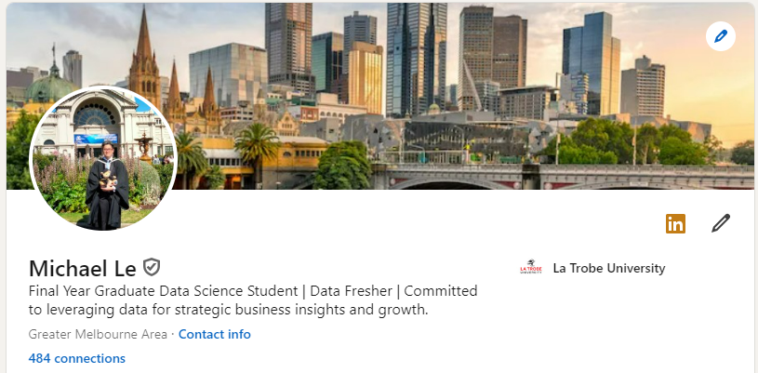

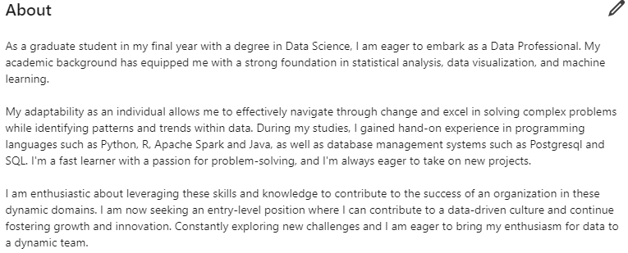

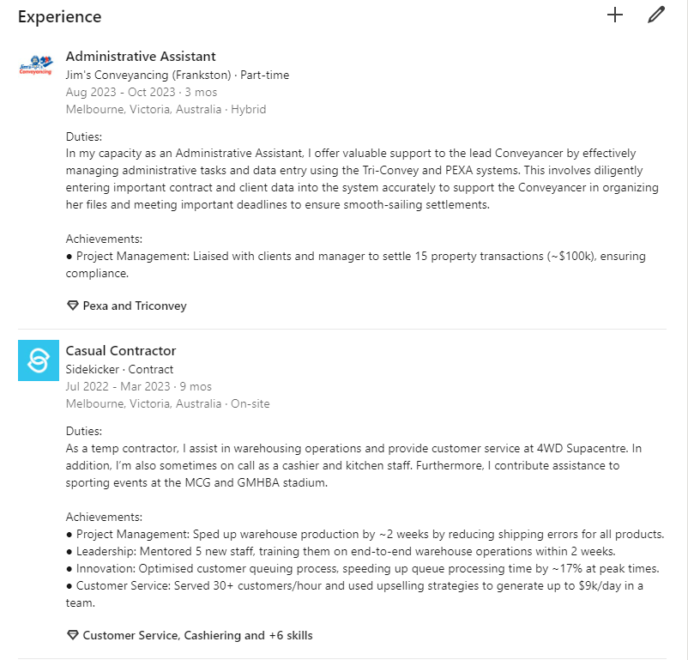

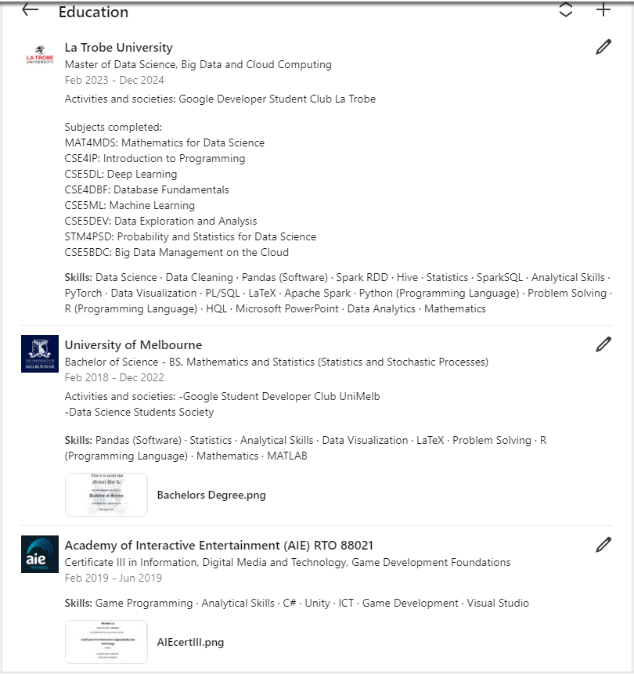

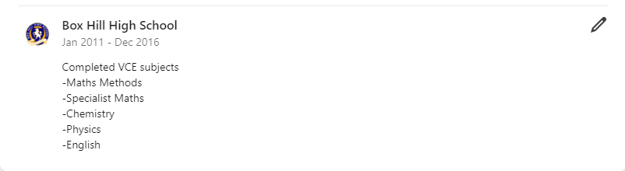

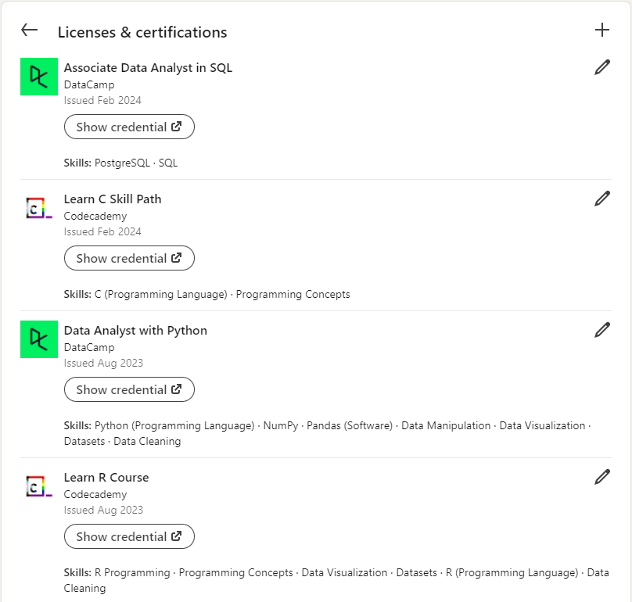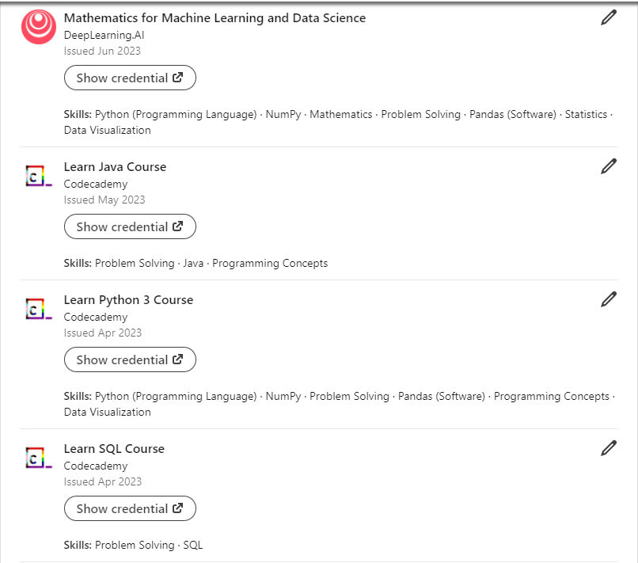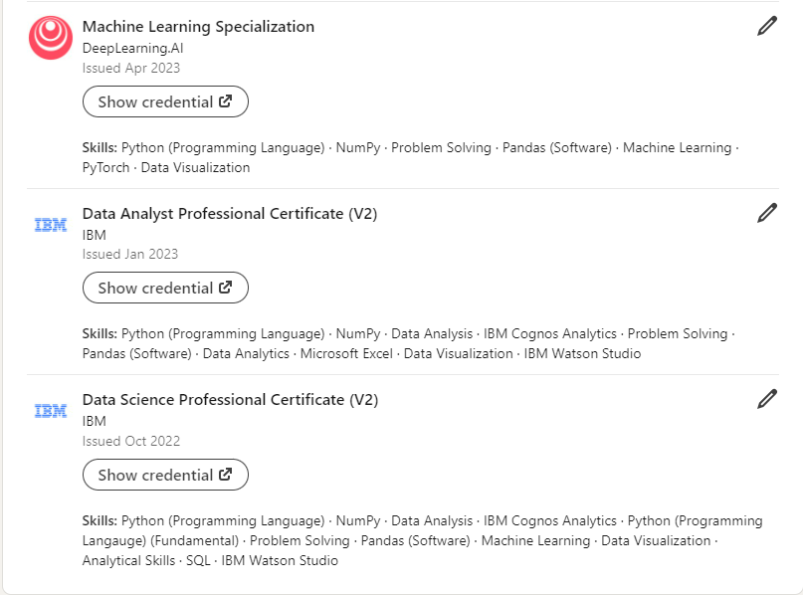

**Projects**

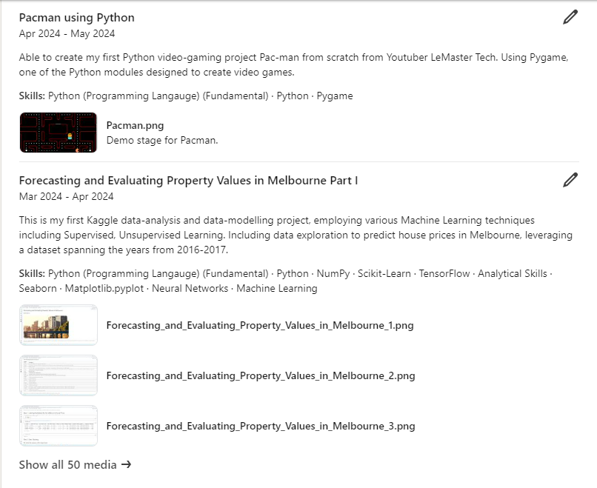

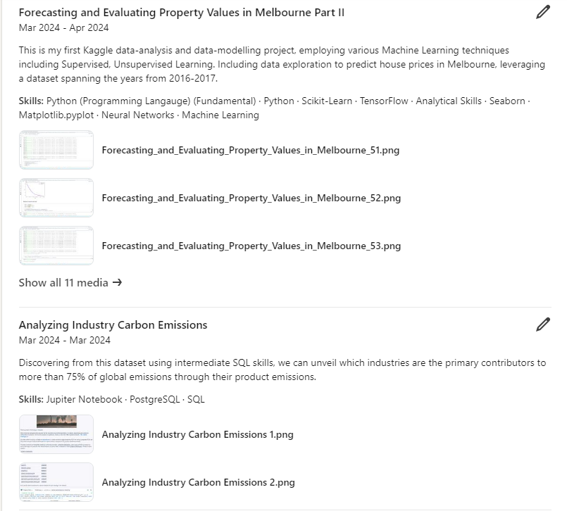

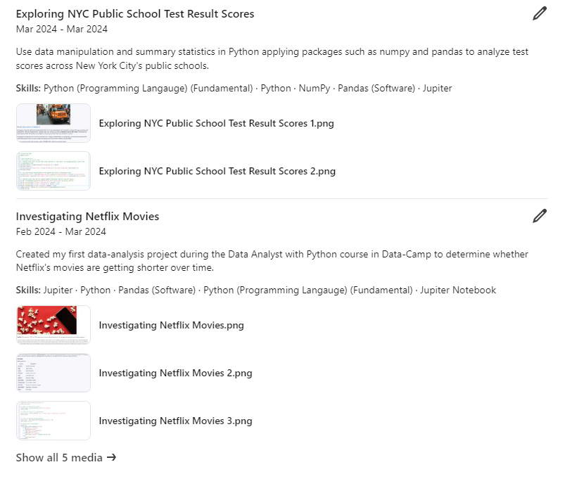

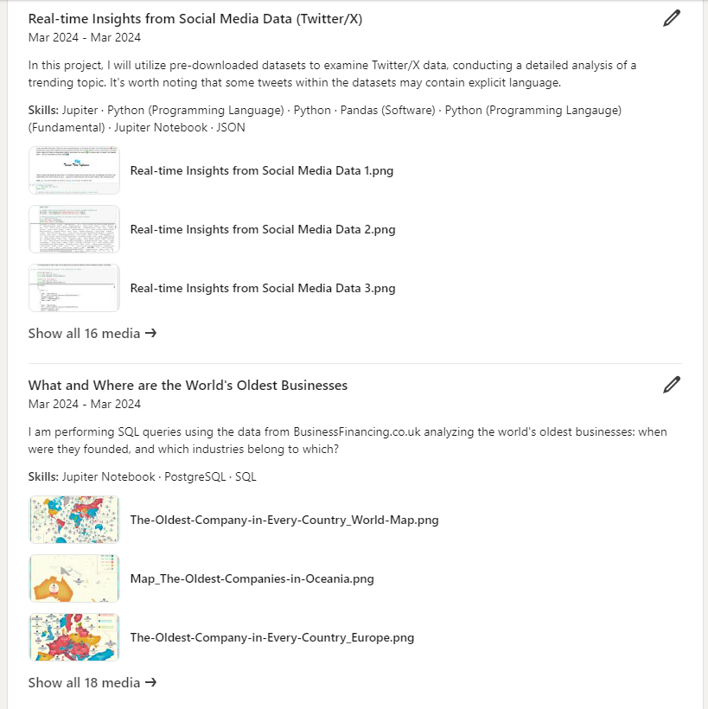

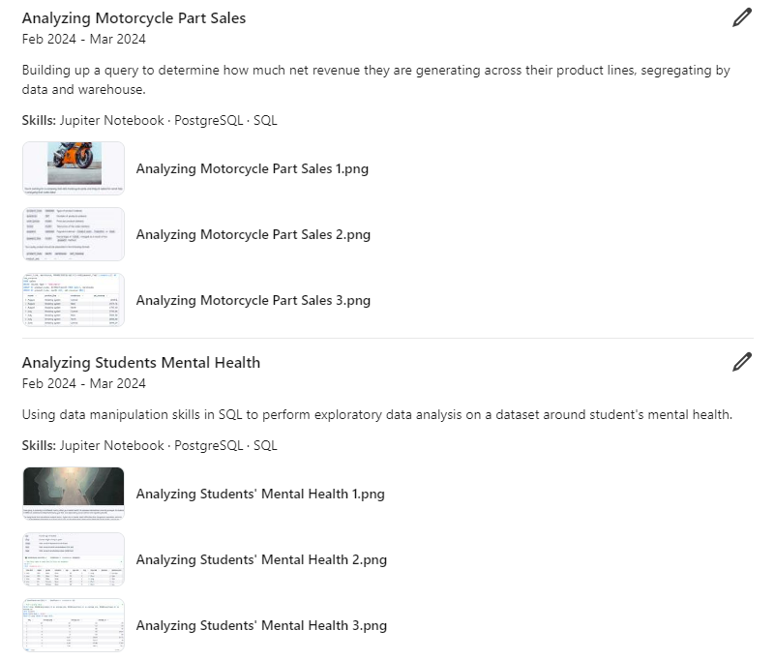

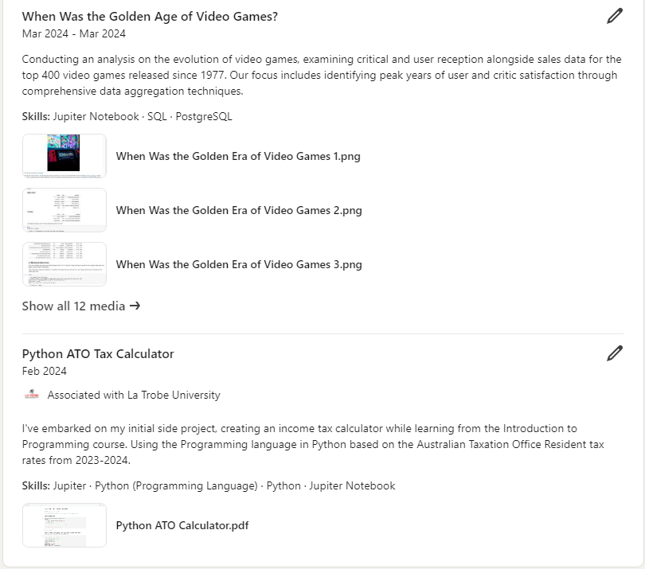

**Skills:**

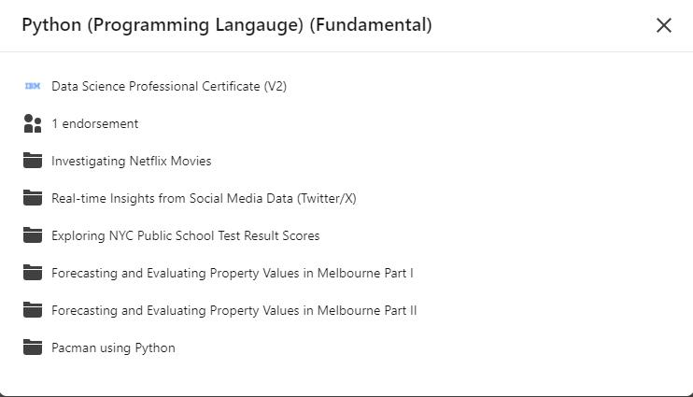

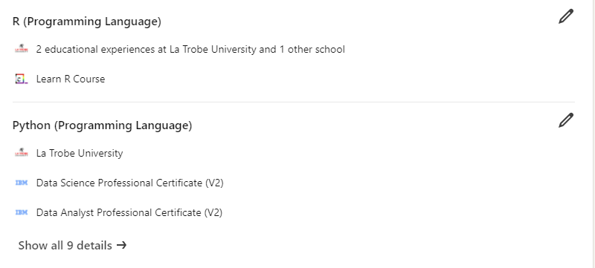

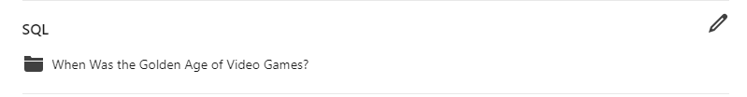

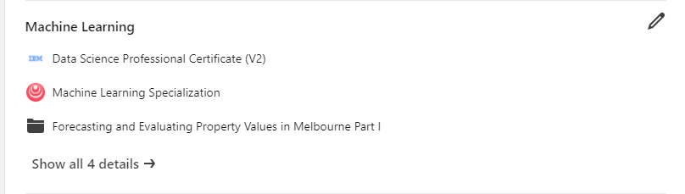

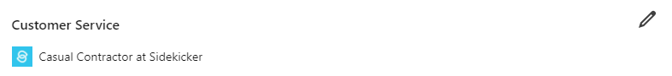

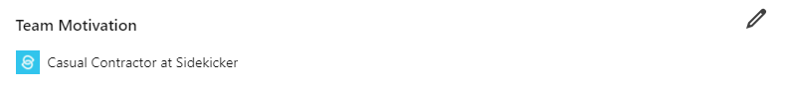

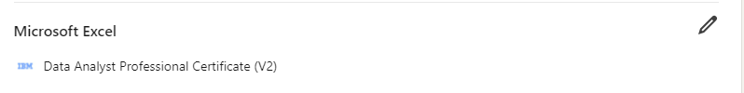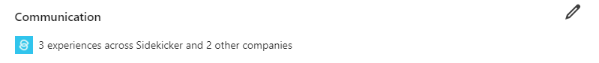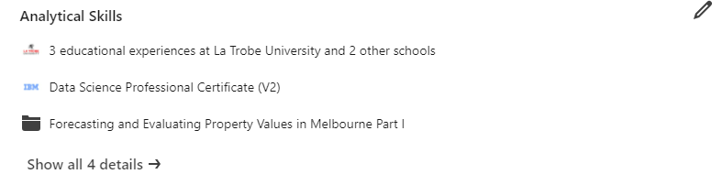

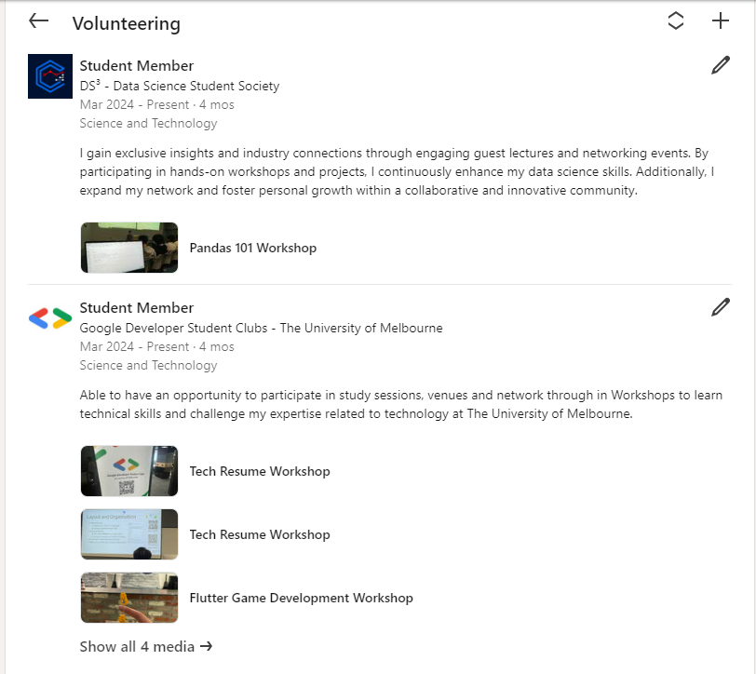

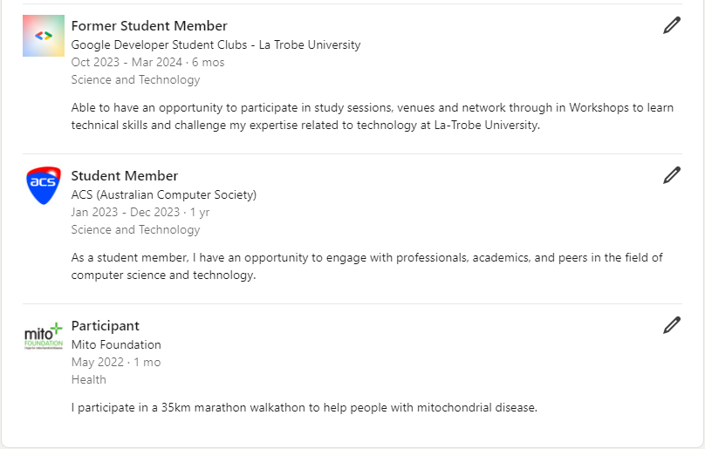

**2. LinkedIn URL:**

<https://www.linkedin.com/in/michael-le-data>

**3. Engagement:**

-Pitch Partners

-KMPG

-EY

-PwC

-Deloitte

-Microsoft

-NAB

-ANZ

-Commonwealth Bank

-Westpac

Additional ones:

-Telstra

-Optus

**4. Networking:**

-Mark Connelly

-Sidakpreet Mann

-Rachel Brooke

-Steven Wang

-Alex Koller

-Jason Duong

-Alex Freberg

-Tina Huang

-Thais Cooke

-Mackenzie Thompson

-Alexander Taylor-Jackson

-Ken Jee

-Greg Hogg

-Abhin Rustagi

-Louka Ewington-Pitsos

-Richard Silberman

-Prerit Rajput

-Michelle (Mei-Ling) Sandford

-Robyn Burrows (Pitch Partners)

-Bonnie Cauchi (Randstad)

-Mustafa Kadir (ACS)